#include<stdio.h>

#include<time.h>

#include<conio.h>

#include<stdlib.h>

#include<dos.h>

#include<graphics.h>

void main()

{

int gd=DETECT,gm;

int x=10,y=200,x1=675,y1=380;

int stangle=35,endangle=140,radius=90;

initgraph(&gd,&gm,"..\\bgi");

while(!kbhit())

{

cleardevice();

setbkcolor(RED);

if(x<640)

{

x+=5;

y+=1;

arc(x,y,stangle,endangle+35,radius);

arc(x,y-110,190,323,radius+2);

circle(x+40,y-60,5);

line(x-90,y-90,x-90,y-8);

}

else

{

x1-=5;

y1-=1;

arc(x1,y1,stangle-30,endangle+4,radius);

arc(x1,y1-110,217,350,radius+2);

circle(x1-40,y1-60,5);

line(x1+90,y1-90,x1+90,y1-10);

}

setcolor(BLUE);

delay(90);

}

closegraph();}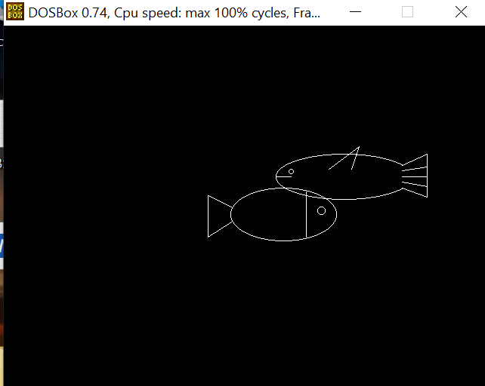#include<iostream>

#include<conio.h>

#include<graphics.h>

#include<dos.h>

#include<ctype.h>

using namespace std;

int main(){

int gd=DETECT,gm;

initgraph(&gd,&gm,””);

int newx=0,newy=0,inc_y=5;

cleardevice();

while(!kbhit()) {

ellipse(520-newx,200,30,330,90,30);

circle(450-newx,193,3);

line(430-newx,200,450-newx,200);

line(597-newx,185,630-newx,170);

line(597-newx,215,630-newx,227);

line(630-newx,170,630-newx,227);

line(597-newx,200,630-newx,200);

line(597-newx,192,630-newx,187);

line(597-newx,207,630-newx,213);

line(500-newx,190,540-newx,150+newy);

line(530-newx,190,540-newx,150+newy);

ellipse(300+newx, 250, 0, 360, 70, 35);

circle(350+newx,245,5);

line(330+newx,220,330+newx,280);

line(200+newx,225,231+newx,240);

line(200+newx,280,231+newx,260);

line(200+newx,225,200+newx,280);

if(newx>=500)

newx=0;

if(newy>=82)

inc_y=-5;

newx=newx+5;

if(newy<=0)

inc_y=5;

newy=newy+inc_y;

delay(50);

cleardevice(); }

cleardevice();

}

